Provider Roster Quick Guide - DRAFT
This compilation of Cohort 1 common errors and reminders will outline how to avoid file errors that could result in a failed roster submission or a future claims processing issue. Please review the Common Errors and Reminders Sections to reduce the possibility a failed submission. There is a quick resource section at the end of the document for your convenience.

Common Errors

What is the Issue: | How to resolve the issue:
File Naming Convention | File Name must match the format indicated in the SPI Guide (page 15).  Example: ALUNtoCarelon_Provider_20240210.txt
File Type – CSV/Pipe Delimited | 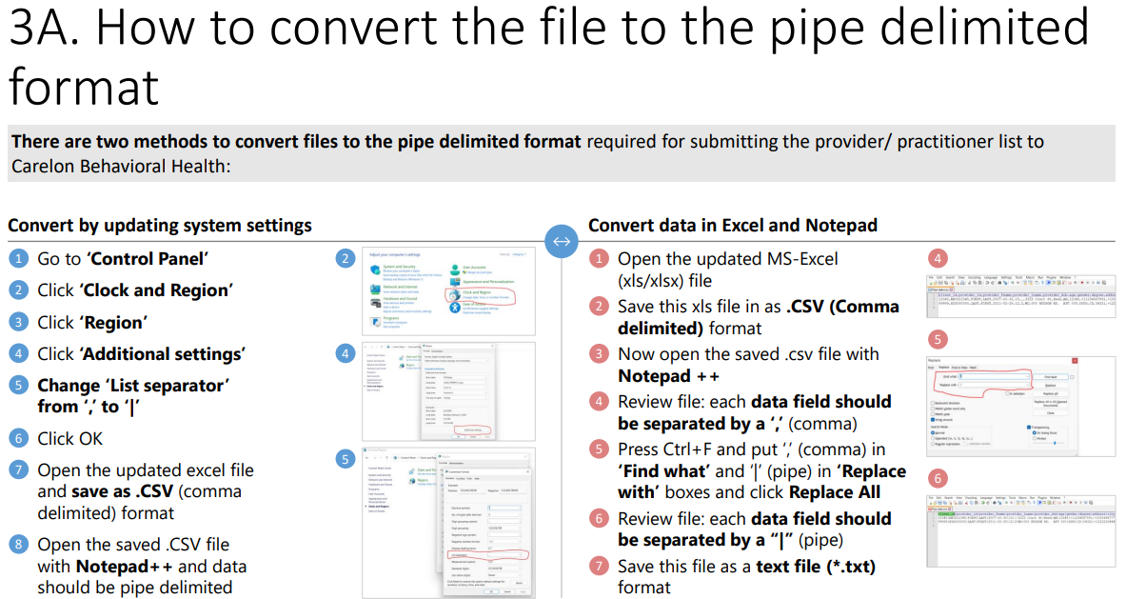
Column Formatting - Date columns not being submitted in the MM/DD/YYYY format. | ALL Date columns MUST be in MM/DD/YYYY format. If the leading zero is not showing for months January through September, please change the format of the cell(s) to “text” before populating data.
Required Columns Incomplete | If the required columns are not populated, the roster submission will fail and need to be corrected and resubmitted. See grid below – Required Fields.
“Provider” Data Input in Group Row Fields | Group Rows only require group information, and provider rows only require provider data. Do not include provider data in group row fields or group data in provider row fields. See grid below – Required Fields which will outline which provider type requires the information.
Insert/Delete Columns in the Template | Modifying the format of the template, by inserting/deleting a column, will result in a file failure. The template is designed to hide all non-essential columns. Please do not modify the template.
ChangeIndicator Column populated with data other than “F”. | ONLY input “F” in the ChangeIndicator Column Field, for all rows (Group/Facility/Provider).

Reminders

- Do NOT add or delete any Columns of the template.
- Fill out ALL required fields of the template.
- Do NOT include punctuation in fields that indicate NO PUNCTUATION.
- Make sure that for every SERVICE location listed, there is a “G” row to accompany it.
- Every practitioner row will need to be associated to a GROUP row at the service location level.
  - Ex. 10 practitioners with one service address WITH one Group = 10 practitioner rows and ONE group row, to show the relationship.
  - Ex. 5 practitioners with one service address AND another 5 practitioners with another service address = 10 practitioner rows and 2 GROUP rows, with corresponding practitioners attached to the respective Group.
- Associate level practitioners must be supervised by a licensed practitioner. Those associate practitioners will be represented on the SPI roster with a Provider Type of “P”. All “P” provider types need to have an “I” provider type to represent the licensed supervisor. Both of those rows will also need to be associated to a “G” row, at the service location level.
  - All of the “P” provider type rows must be linked to a supervisor (type “I”) row.
  - All “I” rows must be linked to a “G” row.
- ALL Date columns MUST be in MM/DD/YYYY format. If the leading zero is not showing for months January through September, please change the format of the cell(s) to “text” before populating data.
- Do NOT delete provider roster “rows” on your template if the practitioner or group is no longer in use. Please simply enter “term” dates in the term date columns.

Required Fields
Required Field’s | Who is required to fill out this field?
ChangeIndicator | Mandatory - All (Group/Provider)
ProviderID | Mandatory - All (Group/Provider)
ProviderTypeID | Mandatory - All (Group/Provider)
FirstName | Mandatory - Provider Only
LastName | Mandatory - Provider Only
PrimaryDegree | Mandatory - Provider Only
ProvNPI | Mandatory - Provider Only
ProvGender | Mandatory - Provider Only
ProvDOB | Mandatory - Provider Only
ProviderEffDt | Mandatory - Provider Only
ProviderExpDt | Mandatory - Provider Only
MailAddr1 | Mandatory - All (Group/Provider)
MailCity | Mandatory - All (Group/Provider)
MailState | Mandatory - All (Group/Provider)
MailZip | Mandatory - All (Group/Provider)
ProviderTaxID | Mandatory - All (Group/Provider)
TaxIDType | Mandatory - All (Group/Provider)
GroupName | Mandatory - All (Group/Provider)
GroupNPI | Mandatory - All (Group/Provider)
BillName | Mandatory - All (Group/Provider)
BillAddr1 | Mandatory - All (Group/Provider)
BillCity | Mandatory - All (Group/Provider)
BillState | Mandatory - All (Group/Provider)
BillZip | Mandatory - All (Group/Provider)
BillPhone | Mandatory - All (Group/Provider)
BillContactEmail | Mandatory - All (Group/Provider)
PrimaryLocFlg | Mandatory - All (Group/Provider)
HandicapFlg | Mandatory - All (Group/Provider)
ServAddrEffDt | Mandatory - All (Group/Provider)
ServAddrExpDt | Mandatory - All (Group/Provider)
ServName | Mandatory - All (Group/Provider)
ServAddr1 | Mandatory - All (Group/Provider)
ServCity | Mandatory - All (Group/Provider)
ServState | Mandatory - All (Group/Provider)
ServZip | Mandatory - All (Group/Provider)
ServPhone | Mandatory - All (Group/Provider)
LowAge | Mandatory - All (Group/Provider)
HighAge | Mandatory - All (Group/Provider)
Plan01 | Mandatory - All (Group/Provider)
ProviderSpecialty1 | Mandatory - Provider Only

Quick Link Resources

Carelon Behavioral Health - CYBHI | https://www.carelonbehavioralhealth.com/providers/forms-and-guides/ca  Under California California Youth Behavioral Health Initiative Fee Schedule (CA TPA)
Carelon ProviderConnect Portal | https://providerportal.carelonbehavioralhealth.com/index.html#/login
CA Department of Health Care Services | https://www.dhcs.ca.gov/cybhi
PAVE | https://pave.dhcs.ca.gov/sso/login.do
CAQH | https://proview.caqh.org/PR/Registration
CYBHI Fee Schedule | CYBHI-Fee-Schedule-DRAFT-Guidance-FOR-PUBLIC-COMMENT.pdf (ca.gov)

For questions, or additional support, please email carelon at cybhitpa@carelon.com.

